MENTAL HEALTH EUROPE – SANTE MENTALE EUROPE

Rue de la Presse 4, 1000, Brussels, Belgium

+32 2 227 27 08

[info@mhe-sme.org](mailto:info@mhe-sme.org) [www.mhe-sme.org](https://www.mhe-sme.org/)

There is no health without mental health

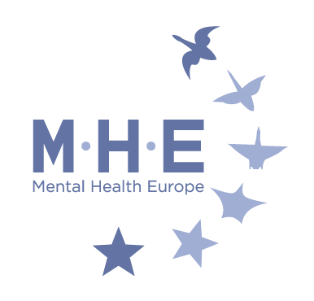

**New Strategy launch tackles ‘urgent mental health priorities’ for Europe**

Today (Thursday, 14th October) mental health partners and allies from across Europe came together to launch a Strategy that outlines some of the most urgent mental health priorities including tackling discrimination and securing equal access to services.

Mental Health Europe (MHE) invited key figures from all over Europe to the launch of its new long-term Strategic Plan 2022-2025 ‘Bridging Policy Making and Human Experience’.

Under MHE’s new vision of building “a Europe where everyone’s mental health and wellbeing flourish across their life course”, the launch featured speakers with lived experiences and mental health expertise to bring their human experiences at the forefront of policy-making and MHE work for the years ahead.

The Strategy launch shone light on the theme of this year’s World Mental Health Day (October 10th), ‘Mental Health in an Unequal World,’ highlighting the many inequalities and risks that people experiencing mental ill health can face including social exclusion and poor physical health.

The Strategy outlines some of the most urgent priorities in mental health in Europe today including:

1. Mainstreaming a human rights-based approach to mental health;
2. Implementing the psychosocial and recovery approach to mental health;
3. Achieving accessible, high-quality, recovery-oriented mental health services in the community;
4. Ensuring real co-creation with experts by experience, their supporters, service providers and other actors;
5. Tackling mental health-related stigma and discrimination.

MHE Director Claudia Marinetti said, *“For over 35 years MHE has led the mental health movement across Europe, taking a human rights, recovery based approach. Now more than ever, MHE feels the need to reinforce a psychosocial and recovery approach to counterbalance the overreliance on a medical model of mental health, which is at risk of being further exacerbated by the current pandemic.*

*“There is a need to move beyond urgency-driven medical solutions and instead adopt a public health, human rights, recovery oriented psychosocial approach to mental health. This is why we have renovated our commitment to work in a holistic way that puts human rights and people with lived experience at the centre of our actions.”*

Catherine Brogan, MHE President said, *“To bring about real change, we have to work through co-creation to shape policies and services that are respectful of the rights of persons with mental health problems and psychosocial disabilities. This means fostering equality-based collaborations involving experts by experience, their family members, supporters, service providers, community and voluntary partners, e policy makers, where all expertise and perspectives as equally valid and valued.”*

[Read Mental Health Europe’s Strategic Plan](https://www.mhe-sme.org/wp-content/uploads/2021/10/MHE_BrochureA4_PROD_DEF.pdf)

###

**About Mental Health Europe**

Mental Health Europe (MHE) is the largest European non-governmental network organisation committed to the promotion of positive mental health and wellbeing. We advocate for the improvement of care, social inclusion and the protection of the rights of (ex)users of mental health services, persons with psychosocial disabilities, their families and carers. We raise awareness to end mental health stigma and discrimination.

Learn more about MHE from [this video](https://www.youtube.com/watch?v=N-m2WOYa-7s). Follow Mental Health Europe on social media. We are on [Twitter](https://twitter.com/MHESME), [Facebook](https://www.facebook.com/mentalhealtheurope/), [LinkedIn](https://www.linkedin.com/company/mental-health-europe) and [Instagram](https://www.instagram.com/mentalhealtheurope/).

**Contact:** Claudia Marinetti, Director Mental Health Europe, +32 2 227 27 09, [claudia.marinetti@mhe-sme.org](mailto:claudia.marinetti@mhe-sme.org)