Contents

Purpose of the toolkit 1
Glossary 2
Colour Code System 4
Introducing the Council of Europe 5
Governing structures of the Council of Europe 5
Relevant Bodies at the Council of Europe 6
Introduction of Human Rights Framework 7
Human Rights Framework of the United Nations 7
Schematic Overview of Core Human Rights Treaty Bodies 8
Bodies and Terminology relevant to the Human Rights at stake 8
What is the Draft Additional Protocol to the Oviedo Convention? 10
Opposition against the draft additional protocol 11
Impact of legislations regulating coercion in psychiatry 12
Growing consensus against involuntary treatment and placement worldwide 14
Advocating against the Draft Additional Protocol 16
Timeline of Decision-Making 16
General process of Decision-Making at the Council of Europe 17
Who can advocate against the draft protocol? 19
Immediate action – what can you do right now? 20
Actions step by step – what can you do throughout the process? 20
At the DH-BIO Committee (Step 1) 21
At the Steering Committee on Human Rights (CDDH) (Step 2) 23
At the Committee of Ministers (Step 4) 26
Public communication and Monitoring our Advocacy 27
General Communication 27
Campaign Landing Page 27
Sample Letters 28
Dissemination Tracker 28
Coordination Group and Contact 29
Frequently Asked Questions 30
My government representative says my country cannot be involved because it has not ratified the Oviedo Convention. Is it true? 30
Why do we use the UN Convention on the rights of persons with disabilities (CRPD) and disability rights for a matter that concerns persons with mental health problems? 30
My government says the additional protocol does not violate the CRPD. Who is right? 30
My government says it has put a reservation / interpretative declaration on article 14 of the CRPD- so it does not have to end involuntary treatment and placement to comply with the CRPD. What to do? 30
Annex 1: Oviedo Convention. List of signatures and ratifications by member state 32

Purpose of the toolkit
The toolkit aims at informing various stakeholders about an initiative of the Council of Europe seeking to regulate the involuntary placement and treatment of persons with mental health problems in psychiatric institutions. It offers tools to advocate against such initiative that, if adopted, would allow for human rights violations all over Europe.
Interested? Join the campaign mailing list: https://www.withdrawoviedo.info/join

We would like to thank all individuals and organisations for their important contributions in the review process of the toolkit, particularly by members of the European Network of (Ex-)Users and Survivors of Psychiatry (ENUSP).

Glossary
Coercive measures: refers to any involuntary, forced or non-consensual measures carried out in mental health services against people with mental health problems. Coercive measures are in violation of the UN Convention on the Rights of Persons with Disabilities (CRPD).

Community Based Support: support in the community which enables people to live independently and to be included in the community. Community based support can be disability specific or mainstream support.

Consent: permission for something to happen or agreement to do something. Consent can only be given by the person concerned, and must be free from undue influence, such as pressure, threat, manipulation, fraud or coercion. Everyone has the right to free and informed consent to treatment, which includes the right to refuse.

Disability: refers to barriers which may hinder the full and effective participation in society on an equal basis with others. Disability does not reside in the person, but in the community.

Disability based discrimination: according to Article 2 of the CRPD “Discrimination on the basis of disability” means any distinction, exclusion or restriction on the basis of disability which has the purpose or effect of impairing or nullifying the recognition, enjoyment or exercise, on an equal basis with others, of all human rights and fundamental freedoms in the political, economic, social, cultural, civil or any other field. It includes all forms of discrimination, including denial of reasonable accommodation. Discrimination is not allowed.

Deinstitutionalisation: the process of developing a range of services in the community regulated by rights-based and outcomes-oriented standards, including prevention, in order to eliminate the need for institutional care.

Free and informed consent: see consent.

Health: according to the World Health Organisation “Health is a state of complete physical, mental and social well-being and not merely the absence of disease or infirmity.”

Institutionalisation: any residential care where residents are isolated from the broader community and/or compelled to live together where they do not have sufficient control over their lives and over decisions which affect them. The requirements of the organisation itself tend to take precedence over the residents’ individualised needs. Institutions are generally characterised by ‘institutional culture’ rather than by their size.

Inclusion: universal equality and non-discrimination in the community, with equal rights, opportunities and resources to all people, in policy and practice, without any exclusion or marginalisation. Being included in the community is a human right.

Involuntary: without consent

Involuntary treatment or placement: similar to Coercive measures: refers to any involuntary, forced or non-consensual measures carried out in or by mental health services against people with mental health problems.

Legal capacity: is a human right and ensures that people have capacity to be a holder of rights and an actor under the law. At its most simple, legal capacity enables people to make decisions for themselves and for those decisions to be recognised including through the law. It refers to all the rights and obligations that come from persons and their interactions with others, that may affect that person and others too. For the purpose of the toolkit, legal capacity is attained by entering an age of majority.

Monitoring: observe, check and review the quality of a service, for example by a health care inspectorate or human rights organisation.

Organisation of persons with disabilities: organisation comprising a majority of persons with disabilities and their families which represent the interests and defend the human rights of persons with disabilities through self-representation and advocacy

Psychosocial disability: a term used to describe barriers in the interaction (disability), characterised by unmet needs for inclusion regarding psychosocial wellbeing, creating an experience of discrimination.

Colour Code System
To make this toolkit as simple and practical as possible we have introduced a colour code system. This system will allow you to quickly scan through the chapters and find the information you are looking for.

BACKGROUND INFORMATION

COUNCIL OF EUROPE STEPS

ACTION

COMMUNICATION

BACKGROUND INFORMATION

Introducing the Council of Europe

Governing structures of the Council of Europe

Council of Europe (CoE) is a regional organisation founded in 1949 to uphold human rights, democracy and the rule of law in Europe. It is composed of 47 countries.

The Council of Europe is different and independent from the European Union. However, all Member States of the European Union are also members of the Council of Europe.

Map of Council of Europe
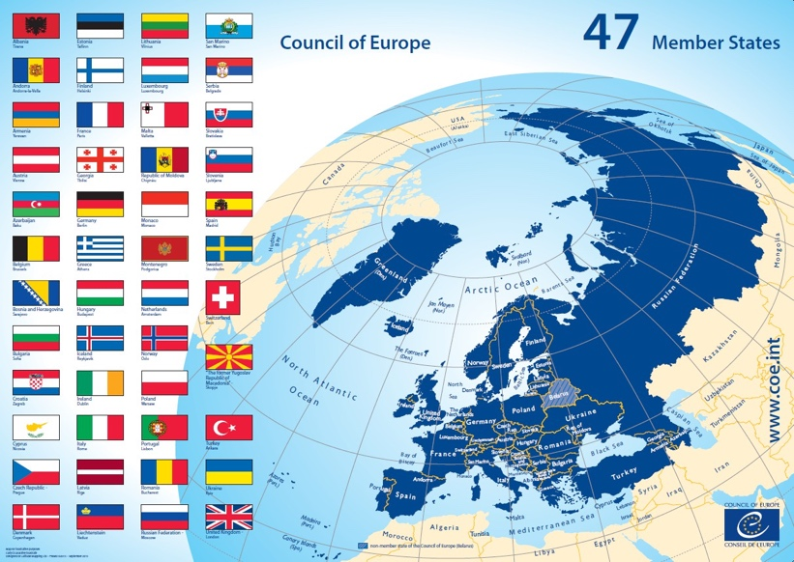

The European Convention on Human Rights is the cornerstone upon which the Council of Europe was founded, uniting its Member States in the firm belief that human rights can be achieved together.

Countries are Member States and have a vote in the Council of Europe.

Committee Members are nominated by Member States of the Council of Europe.
Through these Committee Members the Member states have a vote in the Council of Europe.

In addition, there is a Permanent representation or permanent mission of a country to the Council of Europe.

Relevant Bodies at the Council of Europe

DH-BIO Committee: Committee of Bioethics: body of the Council of Europe mandated to conduct intergovernmental work on the protection of human rights in the field of biomedicine. Each country can be represented. This committee works on the Draft Additional Protocol to the Oviedo Convention.

Committee of Ministers: decision-making body of the Council of Europe. It is composed of the Foreign Ministers of the 47 member states. The Holy Sea, Japan, Mexico and the US are observer states in the Committee of Ministers. This Committee has the final decision-making power over the Draft Additional Protocol to the Oviedo Convention.

CDDH – Steering Committee for Human Rights: set up by the Committee of Ministers, it conducts the intergovernmental work of the Council of Europe in the human rights field in the light, in particular, of the Council of Europe legal standards and the relevant jurisprudence of the European Court of Human Rights. It advises and gives its legal expertise to the Committee of Ministers on all questions within its field of competence.

Commissioner for Human Rights: independent body promoting awareness of and respect for human rights in the Member States of the Council of Europe. Since April 2018, Mrs. Dunja Mijatović from Bosnia-Herzegovina took office as the Council of Europe’s Human Rights Commissioner, and her mandate is calling to withdraw the Draft Additional Protocol to the Oviedo Convention.

CPT: Committee on the Prevention of Torture: monitors compliance of member states to article 3 of the European Convention on Human Rights. The CPT issues reports of monitoring visits to places of deprivation of liberty, including psychiatric institutions and prisons. The CPT has been endorsing the development of the Draft Additional Protocol to the Oviedo Convention.

PACE: Parliamentary Assembly: A large assembly of political representatives being the consultative body of the Council of Europe. It brings together 324 delegates (plus 324 substitutes), who are democratically elected members of parliament in their respective countries. PACE issued the Resolution 2291 (2019) “Ending coercion in mental health: the need for a human rights-based approach”, calling to withdraw the Draft Additional Protocol to the Oviedo Convention.

Conference of INGOs: the chief body representing the INGOs enjoying participatory status with the Council of Europe. INGOs are international non-governmental organisations. The Conference of INGOs has spoken out against the Draft Additional Protocol to the Oviedo Convention.

Secretary General: the head of the secretariat of the Council of Europe. The Secretary General has the overall responsibility for the strategic management of the Council of Europe. Ms Pejčinović Burić was elected in June 2019.

BACKGROUND INFORMATION

Introduction of Human Rights Framework

Human Rights Framework of the United Nations

The United Nations (UN) is an international organisation founded in 1945, bringing together currently 193 Member States guided by its founding Charter: The Charter of the United Nations. Each of the 193 Member States is a member of the General Assembly of the United Nations.

Countries are Member States, and have a vote in the United Nations. Countries that have ratified UN Conventions are called States Parties. Not all Member States ratified all the UN Conventions.

Members of the UN Committee on the Rights of Persons with Disabilites are nominated by Member States of the UN Convention on the Rights of Persons with Disabilities and elected by voting at the Conference of State Parties at the UN headquarters in New York.

In addition, there are permanent representations or permanent missions of states to the United Nations in Geneva and New York City.

Schematic Overview of Core Human Rights Treaty Bodies
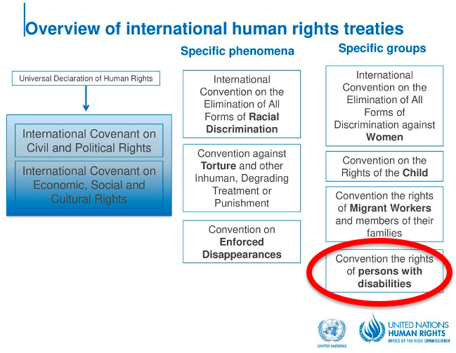

Bodies and Terminology relevant to the Human Rights at stake

CRPD: the United Nations Convention on the Rights of Persons with Disabilities is a human rights treaty reaffirming that all persons with disabilities are entitled to all human rights and fundamental freedoms on an equal basis with others. The CRPD shifts the paradigm from exclusion to inclusion, and replaces the outdated “incapacity-approach” with understanding that disability is a social construct, and inclusion depends on support. The CRPD is ratified by 46 of 47 Member States of the Council of Europe.

CRPD Committee: United Nations Committee on the Rights of Persons with Disabilities: is a committee of independent experts which monitors implementation of the CRPD by the States Parties. The CRPD Committee has published a statement calling publicly on State Parties to oppose and withdraw the Draft Additional Protocol to the Oviedo Convention.

OHCHR: United Nations Office of the High Commissioner on Human Rights is a department of the Secretariat of the United Nations that works to promote and protect the human rights that are guaranteed under international law and stipulated in the Universal Declaration of Human Rights of 1948.

States Parties to the CRPD: Countries which have signed and ratified the CRPD and have committed to making the rights of persons with disabilities a reality.

Treaty Bodies (of the United Nations): committees of independent experts that monitor implementation of the core international human rights treaties, such as the UN CRPD Committee or CEDAW Committee.

SPT: Subcommittee on the Prevention of Torture (of the United Nations) The Subcommittee on Prevention of Torture and other Cruel, Inhuman or Degrading Treatment or Punishment (SPT) is a treaty body in the United Nations human rights system. The SPT monitors compliance of State Parties under the UN Convention Against Torture.

At the National Level

Equality Body: independent national organisation in charge of promoting equality, assisting victims of discrimination, and monitoring and reporting on equality issues. Their exact mandate varies from one country to another.

Ombudsperson: independent national organization in charge of promoting equality, assisting victims of discrimination, and monitoring and reporting on equality issues. Their exact mandate varies from one country to another.

NHRI: National Human Rights Institution: state-mandated body, independent of government, with a broad constitutional or legal mandate to protect and promote human rights at the national level. Their exact mandate varies from one country to another.

NPM: National Preventive Mechanism: state-mandated body, independent of government, with a mandate in charge of preventing torture and other cruel, inhuman or degrading treatment or punishment. Their exact mandate varies from one country to another.

BACKGROUND INFORMATION

What is the Draft Additional Protocol to the Oviedo Convention?
The Draft Additional Protocol to the Oviedo Convention is an additional protocol that is being drafted to supplement the Oviedo Convention.

The Oviedo Convention, officially called the Convention on Human Rights and Biomedicine, is an international convention adopted in 1997 by the Council of Europe, which lays down a series of principles and prohibitions concerning bioethics, medical research, consent, rights to private life and information, organ transplantation, public debate, etc.

It is the only international legally binding instrument on the protection of human rights in the biomedical field. It establishes that human rights must come before other considerations in the field of biomedicine.

However, several of its provisions are outdated in light of the UN Convention on the Rights of Persons with Disabilities (CRPD) adopted in 2007 by the United Nations. For example, Article 6 of the Oviedo Convention maintains incapacity to consent based on disability. Article 7 authorises involuntary treatment against persons with psychosocial disabilities in particular in relation to their disability, which is viewed as a health condition requiring treatment.

Prior to the entry into force of the CRPD, in 2004, the Committee of Ministers issued a recommendation Rec(2004)1016, which requested the Bioethics Committee to produce a Draft Additional Protocol to the Oviedo Convention with the scope of regulating involuntary placements and treatment.

In 2014, the Committee of Bioethics of the Council of Europe started to work on a “draft additional protocol concerning the protection of human rights and dignity of persons with mental disorder with regard to involuntary placement and involuntary treatment” (“draft additional protocol to the Oviedo Convention”). This draft protocol focuses on creating a legal framework on involuntary placement and treatment of persons experiencing mental health problems.

BACKGROUND INFORMATION

Opposition against the draft additional protocol
We oppose this draft additional protocol because it is against international human rights law, and risks to increase human rights violations in psychiatry. In particular our objections are:

- Involuntary treatment and placement in psychiatry is prohibited under the UN Convention on the Rights of Persons with Disabilities. It breaches, among others, the rights of non-discrimination, legal capacity, liberty and security, and health. The CRPD is ratified by 46 of 47 Member States of the Council of Europe.
- The adoption would create a legal conflict between the obligations of States under the regional level (Council of Europe) and the international level (CRPD). Two different standards will apply in European States that ratified the CRPD.
- It risks solidifying institutionalisation of persons with disabilities, while the practice is condemned by the CRPD, the Committee on the Rights of Persons with Disabilities, and the Special Rapporteur on the Rights of Persons with Disabilities. Countries that have adopted similar legislation on involuntary treatment and placement than is enshrined in the draft additional protocol, have seen an increase of coercion in psychiatry.
- It goes against the paradigm shift and growing consensus against coercion that is emerging within the United Nations and the medical community.

Our opposition to the draft is shared by international experts such as:

- the UN Committee on the Rights of Persons with Disabilities
- the Special Rapporteur on the rights of persons with disabilities
- the Special Rapporteur on the Right to Health
- the Working Group on Arbitrary Detention
- the Parliamentary Assembly of the Council of Europe
- the Commissioner of Human Rights of the Council of Europe

National Human Rights Institutions, Equality Bodies and human rights organisations have also questioned and opposed the draft additional protocol. See for instance:

- Human Rights Watch Letter to Mr. Jagland on the Additional Protocol to the Oviedo Convention
- Human Rights Watch: What Does the Council of Europe Have Against People with Disabilities?
- European Network of National Human Rights Institutions, Statement on the Draft Additional Protocol to the Oviedo Convention
- French Défenseur des droits

A non-exhaustive list of statements of various actors against the draft additional protocol is available here: https://www.edf-feph.org/newsroom-news-compilation-statements-opposing-draft-protocol-oviedo-convention-council-europe/.

BACKGROUND INFORMATION

Impact of legislations regulating coercion in psychiatry
Increase of coercive practices
In the past decades, recourse to involuntary treatment and placement in mental health settings has increased in Europe. This is also the case in the countries where so-called restrictive laws were introduced with the aim of reducing recourse to such measures.

A report from the Parliamentary Assembly of the Council of Europe “Ending coercion in mental health: the need for a human rights-based approach” notes that the increase of coercion mainly results from a culture of confinement which focuses and relies on coercion. For example, France is reported to be one of the European countries that has the highest rates of involuntary placement, with a 15% increase in psychiatric coercion since the 2011 law reform, the objective of which was to strengthen the rights of forcibly hospitalised patients. In the Netherlands, the trend is similar, despite the government’s intentions to reduce the number of involuntary measures.

Amongst the 36 countries surveyed in a survey from Mental Health Europe, the only countries that report a decrease in the use of coercive measures are Finland and Germany, following legislative changes and targeted programmes to reduce the use of coercion in psychiatry.

Detrimental effects
Many organisations, including the European Network of Users, Ex users and Survivors of Psychiatry (ENUSP), Mental Health Europe, the EU Fundamental Rights Agency, and Human Rights Watch have been raising the alarm about the harm that is being done by institutionalisation and by coercive measures.

Being subjected to measures such as institutionalisation, solitary confinement, restraints and forced administration of psychopharmaceuticals are traumatising events. According to the report of the Parliamentary Assembly, sociological fieldwork research on persons with mental health problems points to overwhelmingly negative experiences and effects of involuntary placement or treatment. Similar testimonies were shared in MHE`s Mapping Exclusion reports looking at involuntary treatment and placement across Europe.

The list of effects following involuntary treatment and placement is long: trauma and fear, pain, humiliation, shame, stigmatisation and self-stigmatisation, irreversible health damage (such as motor coordination difficulties, hormonal changes, changes in brain tissues, memory loss), mistrust in the healthcare system and deterrence to adhere to treatment in the future – to just name a few.

ENUSP furthermore reports the following about the legislation on coercion:

- Impunity: These European standards pose significant barriers for anyone submitting complaints about deprivation of their liberty or harm by coercion under mental health laws, because detention based on a psychosocial disability or mental health problem is then perceived as “lawful”, and subsequently the courts would not find that the law was violated or that a breach of their own interpretation of human rights has been committed. Impunity at the European level solidifies impunity at the national level.

- The excuse of “Lack of alternatives”: Since coercion has gone hand in hand with impunity at all levels for decades, States have been allowed leeway to use cheap and harmful measures of social control and avoid investments in the development of supportive mental health services based solely on free and informed consent. Legislation seeks to justify coercion “in the absence of alternatives”. Yet, the absence of alternatives appears to dominate the current situation in most countries, which has made the supposed “last resort option” of involuntary treatment a widespread default practice, causing thousands of people to suffer. The claimed “absence of alternatives” has become an excuse which stimies all further efforts.

- Decades of torture instead of dignity: The European assumption that forced interventions would “protect dignity and human rights” do not correspond at all with the lived experience of those subjected to these practices and detained on this basis. In many places in our “developed” countries, there are still horrible and unacceptable situations in institutions. Persons with disabilities report that coercion causes fear and trauma which is recognized by the United Nations. Their testimonies and research show that coercion does not result in safety or wellbeing, but brings suffering without support, and therefore the risk of problems and escalation only increases. Forced interventions do not truly protect the human rights of those concerned, but amount to torture and ill-treatment and have nothing to do with dignity.

In conclusion, it has never been about the rights and needs of the people concerned.

BACKGROUND INFORMATION

Growing consensus against involuntary treatment and placement worldwide
The opposition against involuntary treatment and placement is growing and an increasing number of human rights experts are speaking out against these practices.
In various reports adopted between 2018 and 2020, the UN Special Rapporteur on the right of everyone to the enjoyment of the highest attainable standard of physical and mental health, spoke out against the involuntary placement of persons with intellectual and psychosocial disabilities to mental health facilities (A/HRC/38/36), excessive medicalisation and discriminatory mental health laws that deprive people of liberty and their autonomy, often based on the myth that “individuals with certain diagnoses are at high risk of perpetuating violence and posing a threat to the public” (A/HRC/41/34). In its latest report, the Rapporteur called States to “undertake the legislative, policy and other measures required to fully implement a human rights-based approach to mental health with the inclusive participation of those with lived experience” (A/HRC/44/48).
In 2020, the UN Special Rapporteur on Torture and Other Cruel, Inhuman or Degrading Treatment or Punishment recognised that “psychiatric intervention based on ‘medical necessity’ or the ‘best interests’ of the patient (…) may well amount to torture” (A/HRC/43/49).
In a resolution adopted in March 2020, the UN Human Rights Council expressed deep concerns that persons with mental health conditions or psychosocial disabilities, including persons using mental health services, continue to be subject to a variety of human rights violations, including overmedicalisation and treatment practices that fail to respect their autonomy, will and preferences. It called on States to promote a paradigm shift in mental health, “through the promotion of community-, evidence- and human rights-based and people-centred services and supports that protect, promote and respect the enjoyment of the rights, autonomy, will and preferences of all persons” and through the involvement of people with psychosocial disabilities and mental health issues.
Similarly, a growing number of practitioners in the medical and scientific community are now questioning the use of coercive measures in mental healthcare. Some have reached the conclusion that all forms of coercive practices are inconsistent with human rights-based mental healthcare. The lack of evidence of their effectiveness is on the other hand accompanied by the evidence that coercive practices such as seclusion and restraint actively cause harm to physical and mental health. Evidence that contests coercive treatment also points at poor health outcomes and drastically shorter life-expectancy of those involuntary treated.

Advocating against the Draft Additional Protocol
COUNCIL OF EUROPE STEPS

Timeline of Decision-Making
Different bodies of the Council of Europe still have to make a final decision on the Draft Additional Protocol.
The main actors are the Committee of Bioethics, the Steering Committee on Human Rights and the Committee of Ministers. The committee members of these three bodies are representatives of member states. This means that the adoption of the protocol would be a decision made by all countries which are members of the Council of Europe. Each country has one vote. Even those that did not ratify the Oviedo Convention.

You can find more information on the structure and different actors of the Council of Europe here: https://www.coe.int/en/web/about-us/structure

Provisional timetable

June 1 – 4, 2021: State delegations vote in Committee of Bioethics’ plenary meeting

September-October 2021 (TBC)
-Decision by Steering Committee on Human Rights
-Non-binding opinion of the Parliamentary Assembly

Fall 2021-Spring 2022 (exact time TBC): Decision by Committee of Ministers. The decision is usually by consensus involving all Member States of the Council of Europe.

COUNCIL OF EUROPE STEPS

General process of Decision-Making at the Council of Europe
As shown in the flowchart below, there are several steps in the process:

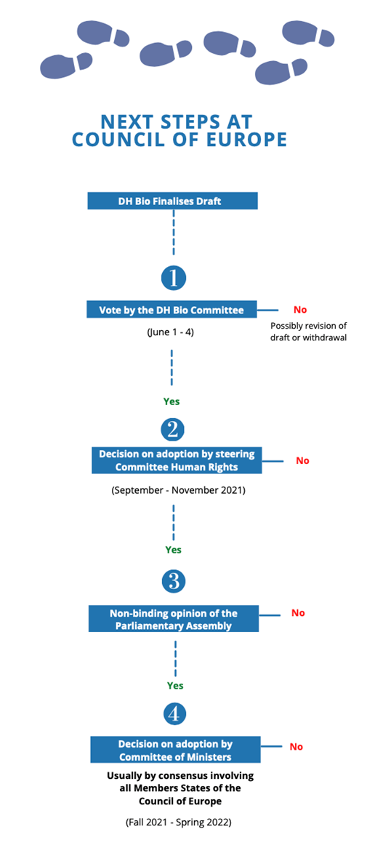
- Voting by the DH-BIO Committee (Step 1): the Secretariat of the DH-BIO Committee circulated a final version of the draft protocol in December 2020 and indicated it will vote on the draft at its plenary meeting on 1-4 June 2021.

From our experience with the DH-BIO Committee in the past years, we believe that the Secretariat and most members of the Committee will aim to adopt the draft additional protocol in June. Previous attempts to convince members to oppose the finalisation were unsuccessful. A majority of the members has no knowledge of the CRPD and international human rights law, and do not consider the protocol violates the CRPD.

- Review by the Steering Committee on Human Rights (CDDH) (Step 2): Once finalised by the DH-BIO Committee, the additional protocol would come under review by the CDDH. Governments of Member States designate one or more representatives of the highest possible rank in the field of human rights. Each member of the committee has one vote. However, in the event that there would be no opposition within the Committee, the protocol may be adopted this body by consensus; without calling for a vote.

The CDDH is composed of national experts that have more expertise on human rights law, and potentially on the CRPD. It also includes observers, such as representatives of the Commissioner for Human Rights and the European Network of National Human Rights Institutions, those cannot vote but can make a statement during the meeting. We believe it is important to inform this body.

- Non-binding opinion of the Parliamentary Assembly (Step 3): the draft additional protocol would be endorsed by the CDDH, the Parliamentary Assembly (PACE) will be asked to issue a non-binding opinion on the content of the protocol.

Over the past years, the PACE issued a report and resolution, encouraging the DH-BIO, and Council of Europe as a whole, to divert its efforts away from the draft additional protocol and towards guidance on voluntary care. Members of PACE could be requested to help convincing the CDDH-members and the various ministers who compose the Committee of Ministers to drop the withdraw additional protocol.

- Decision and/or Voting by the Committee of Ministers (Step 4): in the final step, the Committee of Ministers would be asked to make a final decision on the draft additional protocol. The Committee of Ministers is composed of representatives of each Member States of the Council of Europe. The “level of representation” meaning which person is coming to the meeting would depend on the political sensitivity of the topic. For instance, it could be a representative working in the permanent representation in Strasbourg, an expert sent from a Ministry, or even the Minister of Foreign Affairs in person.

At this stage, we do not know what the level of representation would be if the additional protocol would arrive at the Committee of Ministers; we also do not know whether the decision would be taken by consensus or be put for a vote. Active campaigning can help to reach a higher level of representation and bring more attention and political pressure to the unacceptable derogation from universal human rights which is proposed under the draft additional protocol to the Oviedo Convention.

ACTION

Who can advocate against the draft protocol?
Anyone can advocate against the draft additional protocol. As an organisation, policy-maker, parliamentarian or individual you can use different advocacy tools, networks and contacts to support this campaign.

We especially encourage the following organizations and their members to take an active role in raising awareness and campaigning against the draft additional protocol:

- Civil society organisations: such as organisations of persons with lived experience, organisations of persons with psychosocial disabilities and/or (ex)-users and survivors of psychiatry, mental health organisations, human rights organisations and so on.
- National Human Rights Institutions or Equality Bodies
- National CRPD independent monitoring frameworks
- Service providers, on mental health and/or other services such as lawyers
- High level representatives, such as human rights experts, Members of (National/European) Parliament, celebrities and so on
- Anyone working at a ministry
- Anyone else advocating to end coercion

A united push is needed to stop the draft additional protocol.
ACTION

Immediate action – what can you do right now?
The goal is to stop the Council of Europe adopting the draft additional protocol to the Oviedo Convention and redirect efforts to the development of guidelines on ending coercion in psychiatry.

Campaigning is needed to create political pressure at national, European and international levels.

It can be useful to create a coalition in your country to advocate against the draft additional protocol and request your country to ask for its withdrawal.

Coalitions can be useful in reaching out to president or prime minister, relevant ministries, ministers, and others.

In the next chapter, you can find the link to a sample letter. We suggest translating it to your language. For this you could use an online translator such as Deepl or Google Translate.

ACTION

Actions step by step – what can you do throughout the process?
As outlined above, the withdrawal of the protocol can happen during the voting during the DH-BIO Committee meeting (1), during the decision process by the CDDH (2), and the final decision by the Committee of Ministers (4).

For all these steps various stakeholders have different possibilities for intervention. This is mainly reasoned in the terms of reference for the different Council of Europe bodies. Although without the right to vote and at their own expenses, some stakeholders have the rights to participate in DH-BIO and CDDH meetings as participants or observers. We have listed those actors below and provided some ideas for intervention.

In the next chapter, you can find the link to a sample letter. We suggest translating it to your language. For this you could use an online translator such as Deepl.
ACTION

At the DH-BIO Committee (Step 1)

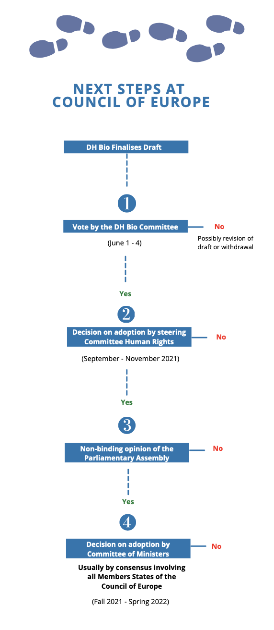

General Action 1: Contact your Ministry and Minister of Health to vote against the draft additional protocol
As mentioned, each member state to the Council of Europe can appoint a representative with the right to vote in the DH-BIO Committee. In theory, the representative should vote following the instruction received by the government, usually the ministry on health.

The Ministry of Health can often be contacted through the official Ministry of Health contact form. Sometimes there is a specific unit in charge of mental health. In some countries the Minister of Health can be contacted directly. The situation may vary from one country to another.

General Action 2: Contact the representative from your country in the DH-BIO Committee
To know the view of the representative from your country in the DH-BIO Committee you can contact them and express your opposition against the additional protocol.

You can find the names of the representatives that attended the last meetings of DH-BIO here. Their contact details are not listed on the website- however you may be able to find them online. Alternatively, or additionally you can contact your national bioethics committee and permanent representation of your country to the Council of Europe.

Specific Action 1: Make a statement at the DH-BIO Meeting in June
The table below mentions a list of stakeholders who can make a statement during DH-BIO meeting on June 1-4, 2021. This includes for instance representatives of WHO, PACE, the Commissioner for Human Rights and “non-governmental organisations, including professional organisations, which could be invited by the DH-BIO to attend specific meetings of the DH-BIO in accordance with CM/Res(2011)24”.

Should you wish to make a request for intervention, you would write to the Secretariat of the DH Bioethics Committee: dgi-cddh-bioethics@coe.int

Make sure you plan sufficient time for registration ahead of the meeting.

Stakeholder | Status within DH Bioethics Committee: Participant | Status within DH Bioethics Committee: Observer
Parliamentary Assembly of the Council of Europe | ✅
Council of Europe Commissioner for Human Rights; | ✅
Conference of INGOs of the Council of Europe | ✅
Consultative Committee of the Convention for the Protection of Individuals with regard to Automatic Processing of Personal Data (T-PD); | ✅
Steering Committee on the Rights of the Child (CDENF) | ✅
European Committee on Legal Cooperation (CDCJ); | ✅
Committee on Transplantation of Organs and Tissues (CD-P-TO) | ✅
Committee on Blood Transfusion (CD-P-TS) | ✅
Committees or other bodies of the Council of Europe engaged in related work, as appropriate | ✅
European Union; | ✅
Observer States to the Council of Europe: Canada, Holy See, Japan, Mexico, United States of America; | ✅
other international organisations: WHO | ✅
other international organisations: UNESCO | ✅
other international organisations: OECD | ✅
Australia |  | ✅
Israel |  | ✅
Conference of European Churches (KEK) |  | ✅
other non-governmental organisations, including professional organisations, which could be invited by the DH-BIO to attend specific meetings of the DH-BIO in accordance with CM/Res(2011)24 |  | ✅

ACTION

At the Steering Committee on Human Rights (CDDH) (Step 2)

General Action 1: Contact your National Human Rights Institution, Equality Body and/or CRPD independent monitoring framework
Similar to the DH-BIO Committee, member states send representatives to the CDDH with a right to vote. Since the names are not publicly available, you can contact your national human rights institution (NHRI) and equality body to inform them about the ongoing issue of the draft additional protocol.

- List and contacts of NHRIs: http://ennhri.org/our-members/
- List and contacts of Equality Bodies: https://www.archive.equineteurope.org/-Equinet-Members-

Very often these bodies also play the role of the CRPD independent monitoring framework or are part of it. If another body plays this role, we recommend that you contact it too.

General Action 2: Contact the national focal point for the CRPD implementation and/or Ministry of Social Affairs
We also recommend you contact the national focal point for the CRPD implementation and monitoring and inform them about the draft which is in violation of CRPD obligations. Usually, these focal points are located within a national ministry, for example the Ministry of Social Affairs. In any case, you may wish to contact the Ministry of Social Affairs.

General Action 3: Identify and contact the representative from your country in the CDDH
To know the view of the representative from your country in the CDDH you can contact them and express your opposition against the additional protocol.

Unfortunately, the names and contacts of the representatives are not publicly available. We advise that you contact the Secretariat of the CDDH: DGI-CDDH@coe.int.

Specific Action 1: Make a statement at the CDDH Meeting in September-November (tbc)
The stakeholders in the table below can participate and make a statement during the Human Rights Steering Committee to be taking place in September-November 2021 (tbc).

You can contact the CDDH Secretariat and the chairs (Morten RUUD, Norway; Hans-Jörg BEHRENS, Germany) to make a request for information: DGI-CDDH-Reform@coe.int.

Make sure you plan sufficient time for registration ahead of the meeting.

Stakeholder | Status within CDDH: Participant | Status within CDDH: Observer
Parliamentary Assembly of the Council of Europe | ✅
Council of Europe Commissioner for Human Rights; | ✅
Conference of INGOs of the Council of Europe | ✅
Congress of Local and Regional Authorities of the Council of Europe | ✅
European Court of Human Rights | ✅
Committees or other bodies of the Council of Europe engaged in related work, as appropriate | ✅
European Union (one or more representatives, including, as appropriate, the European Union Agency for Fundamental Rights (FRA)); | ✅
Observer States to the Council of Europe: Canada, Holy See, Japan, Mexico, United States of America; | ✅
other international organisations (Organisation for Security and Co-operation in Europe (OSCE) / Office for Democratic Institutions and Human Rights (ODIHR), Office of the United Nations High Commissioner for Human Rights) | ✅
Belarus |  | ✅
non-member States with which the Council of Europe has a Neighbourhood Partnership including relevant co-operation activities |  | ✅
European Network of National Human Rights Institutions (ENNHRI) |  | ✅
Non-governmental organisations (Amnesty International, International Commission of Jurists (ICJ), European Trade Union Confederation (ETUC), International Federation of Human Rights (FIDH), European Roma and Travellers Forum) |  | ✅

ACTION

At the Committee of Ministers (Step 4)

General Action: Contact your government and Ministry of Foreign Affairs to oppose the draft additional protocol
In this stage, member states would be asked to make a final decision on the draft additional protocol during a meeting of the Committee of Ministers. We aim to identify 5-10 member states (“champions”) prior to the meeting to declare their opposition/vote against the draft additional protocol.

While we communicate possible states to contact at a later stage through our mailing list, it will be crucial to raise awareness at the Ministry of Foreign Affairs, the Ministry of Health, and the government as a whole, and to ensure they are informed about the violations created by the additional protocol, well ahead the meeting. See a complete list of ministers of foreign affairs here.

Alternatively, you can try to contact the Ministry of Foreign Affairs through the Permanent Representatives of the Member States of the Council of Europe (Ministers’ Deputies).

Additionally, you can again contact the CRPD independent monitoring framework in your country to discuss the issue with the Ministry of Foreign Affairs, either through a bilateral discussion or in a plenary discussion during governmental cabinet meetings.

Public communication and Monitoring our Advocacy

COMMUNICATION

General Communication
Next to the above-mentioned actions throughout the Council of Europe you can use public communication tools to draw attention on the issue.

You can use for instance:
- Use social media (e.g. Twitter, Facebook) to reach out to policy makers and share your opposition. You can use the hashtag #WithdrawOviedo and the tagline Coercion Is Not Care.
- Contact journalists and offer writing or contributing to an article about the draft additional protocol and coercion in psychiatry
- Create a dedicated webpage in your language with your position, statement and own tools for advocacy

COMMUNICATION

Campaign Landing Page
To circulate information and updates we have created a landing list with a mailing list to which you can subscribe. Through this mailing list we will regularly send updates, and also channel calls for action. On the landing page you will find further information, updates on the opposition, sample letters, hashtags suggestions and other useful tools.

You can access the Landing Page by clicking on: https://withdrawoviedo.info/join

COMMUNICATION

Sample Letters
As discussed in the chapter above, depending on your relationships and networks, it might make sense to target specific bodies in your country.

For this we have prepared sample letters which you can find under the following link: https://docs.google.com/document/d/15c66rEn3bVV1me4IzOcGbEp6NrCiOGeKXTz22dHtuNw/edit You can also find them on campaign’s landing page: https://withdrawoviedo.info/join

We prepared sample letters to address the following actors:
- High level letter to government representatives
- Letter to Permanent representations to the Council of Europe
- Letter to CRPD independent monitoring mechanism
- Letter to Members of your parliament and/or member of the European Parliament from your country
- Letter to National Human Rights Institution / Equality Body

All sample letters will be continuously updated in line with the steps at the Council of Europe.

COMMUNICATION

Dissemination Tracker
To better track our advocacy efforts, we have created a Dissemination Tracker which you can find below. Once you have started an advocacy initiative, whether contacting your ministry or publishing a position statement, kindly fill in this form so we can better monitor our progress.

This is very important for us to have an overview of actions undertaken all over Europe and will help us to support your efforts. The information sent to us can remain confidential at your request.

We will continuously inform participants about the progress of our advocacy on a national and European level.

You can find the Tracker here: https://docs.google.com/forms/d/e/1FAIpQLSf38_X4An1fQIjhp4lBUQM-oICOquNGZdYpnTEjJMxeeCiyKg/viewform

COMMUNICATION

Coordination Group and Contact
To monitor the advocacy initiatives, we have established a Coordination Group including organisations of persons with disabilities and of (ex-)users and survivors of psychiatry, mental health organisations, human rights organisations and other interested stakeholders. This group has been active for many years, advocating against the development of the draft additional protocol, participating in the DH BIO meetings. Feel free to reach out to:

- EDF – European Disability Forum: Marine Uldry at marine.uldry@edf-feph.org
- MHE – Mental Health Europe: Jonas Bull at Jonas.bull@mhe-sme.org

BACKGROUND INFORMATION

Frequently Asked Questions

My government representative says my country cannot be involved because it has not ratified the Oviedo Convention. Is it true?
The draft additional protocol will be adopted by the Council of Europe and all member states have to approve it, even if they did not ratify the Oviedo Convention. Each country has a say! However, only the countries that ratified the Oviedo Convention can ratify the additional protocol, if adopted.

Why do we use the UN Convention on the rights of persons with disabilities (CRPD) and disability rights for a matter that concerns persons with mental health problems?
Under the CRPD, persons experiencing mental health problems are considered “persons with psychosocial disabilities”. This is true even if the person has recovered and do not see themselves as persons with disabilities.

The CRPD is a human rights instruments which scope apply to practices in mental health services and psychiatry. Other international human rights treaties and their monitoring bodies have criticised involuntary treatment and placement.

My government says the additional protocol does not violate the CRPD. Who is right?
The CRPD Committee has stated on several occasions that the draft additional protocol violates the rights of persons with disabilities. As UN expert monitoring body, the CRPD Committee is the most legitimate body to assess whether the protocol comply or not with the CRPD. It called on several occasions European countries to oppose to the draft protocol and adopt measures to end involuntary treatment and placement.

My government says it has put a reservation / interpretative declaration on article 14 of the CRPD- so it does not have to end involuntary treatment and placement to comply with the CRPD. What to do?
A reservation on an article of a treaty means that a State exclude the application of this article in their application in the country. An interpretative declaration means that the State do not intend to exclude or modify the scope of certain obligations arising from the treaty but put on record its understanding of a particular provision. The Netherlands and Ireland have issued interpretative declaration on article 14 of the CRPD on the right of liberty and security and allow involuntary treatment. See the interpretative declarations here.

In that case, it is important to recall that not only the CRPD but other international human rights treaties and their monitoring bodies have criticised involuntary treatment and placement, including practices such as restraint, forced medication, and electro-convulsive therapy. See the section of the toolkit on background information.

Other questions we have not answer? Please contact us!

BACKGROUND INFORMATION

Annex 1: Oviedo Convention. List of signatures and ratifications by member state
Oviedo, 04/04/1997- Treaty open for signature by the member States, the non-member States which have participated in its elaboration and by the European Union, and for accession by other non-member States

01/12/1999 - 5 Ratifications including 4 member States

For latest update see: https://www.coe.int/en/web/conventions/full-list/-/conventions/treaty/164/signatures?p_auth=wzRSnmOH

Member State | Signature | Ratification
Albania | ✅ | ✅
Andorra
Armenia
Austria
Azerbaijan
Belgium
Bosnia & Herzegovina | ✅ | ✅
Bulgaria | ✅ | ✅
Croatia | ✅ | ✅
Cyprus | ✅ | ✅
Czech Republic | ✅ | ✅
Denmark | ✅ | ✅
Estonia | ✅ | ✅
Finland | ✅ | ✅
France | ✅ | ✅
Georgia | ✅ | ✅
Germany
Greece | ✅ | ✅
Hungary | ✅ | ✅
Iceland | ✅ | ✅
Ireland
Italy | ✅
Latvia | ✅ | ✅
Liechtenstein
Lithuania | ✅ | ✅
Luxembourg | ✅
Malta
Monaco
Montenegro | ✅ | ✅
Netherlands | ✅
North Macedonia | ✅ | ✅
Norway | ✅ | ✅
Poland | ✅
Portugal | ✅ | ✅
Republic of Moldova | ✅ | ✅
Romania | ✅ | ✅
Russian Federation
San Marino | ✅ | ✅
Serbia | ✅ | ✅
Slovak Republic | ✅ | ✅
Slovenia | ✅ | ✅
Spain | ✅ | ✅
Sweden | ✅
Switzerland | ✅ | ✅
Turkey | ✅ | ✅
Ukraine | ✅
United Kingdom

